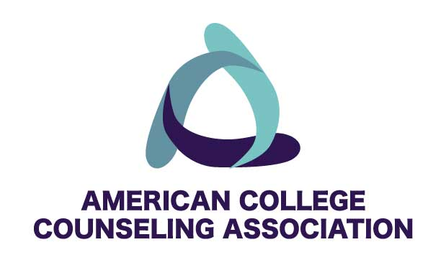
Award Nomination Form (Submit by e-mailing this form to Lisa Adams, ladams@westga.edu)
Award: (select one)
□ Professional Leadership | □ Meritorious Service: community/technical college
□ Meritorious Service: enrollment under 5,000 | □ Outstanding Professional Contribution to Knowledge
□ Meritorious Service: enrollment over 5,000 | □ Graduate Student Meritorious Service
□ Advocacy for College Counseling | □ Research Award
□ Counselor of the Year | □ Director of the Year

Name of Nominee:
Address:
E-mail address:
Phone number:
(Attach Nominee’s vita if available)
Brief description of the nominee’s job setting including information pertinent to the award.

Brief reason for nomination. (Why does this person deserve this award?)

Nominators name:
E-mail address:
Phone #:

